COMPANY PROFILE

Head Office
Blazon House # 45
Rawalpindi Cricket Stadium,
Double Road, Rawalpindi,
Pakistan.

↓
↓ ↓

HEAD OFFICE

Blazon House
45-Rawalpindi Cricket Stadium
Double Road Rawalpindi
Phone: +92-(51) 4415728, 4423928, Fax: +92 (51) 4580577 Help Line: 0321 5555400
Email: info@blazon.com.pk
Website: www.blazon.com.pk

BRANCH OFFICE (LAHORE)

Blazon, 3rd Floor, Umar Market, Sanda Road, Lahore, Pakistan.
Email: lhr@blazon.com.pk

BRANCH OFFICE (PESHAWAR)

CONTACT PERSON
Javed Khan
Tell: 0300-9899831
Email: psh@blazon.com.pk

CONTENTS:

- Introduction
- History
- Objectives
- Management & Structure
- Registration Certificates
- List of Clients
- Supply Orders
- L/C Documents
- Foreign Principals & Authorization Letters
- Bank Statements

HISTORY:

In 1996 Ahmar Zaman Khan a young MBA (Finance & Management) laid down the foundation of Blazon Diagnostics and Blazon High Tech at Rawalpindi / Islamabad. Initially it was a small organization with a limited but experienced and efficient staff while now it is grown up and has become a large scale organization with a number of personal working in various departments to the status of country wide presence. Hard working Ahmar Zaman Khan looking after the business himself with a great deal of experience and patience. His personal devotion brought BLAZON amongst the companies people trust. Mr. Muhammad Shoaib Khan, his assistant, now the General Manager of the company played a significant role to establish this organization.
Blazon is proud to achieve the RCCI ACHIEVEMENT AWARD 2010. The Rawalpindi Chamber of Commerce and Industry awarded the BEST ACHIEVEMENT award for 2010 to Blazon for the promotion of business in Azad Jammu & Kashmir, northern areas and the Rawalpindi/ Islamabad region by the RCCI President Kashif Shabbir.

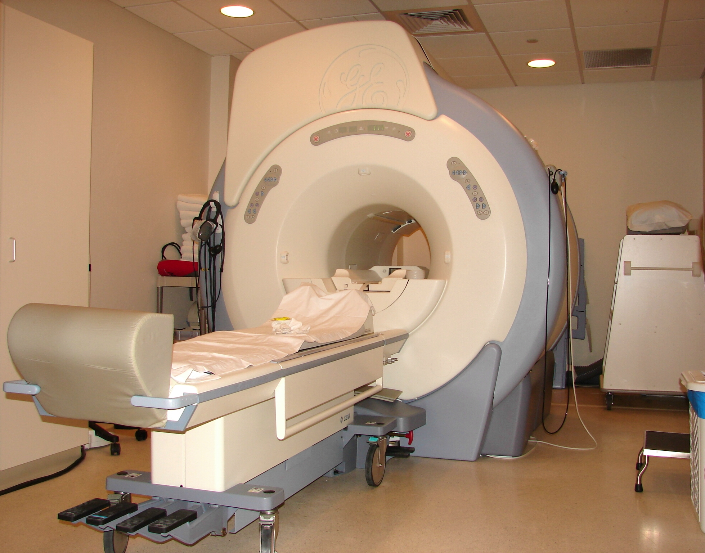

OBJECTIVES:

Blazon Diagnostic is a country wide organization which is providing an integrated end to technology based solutions and backing up services to fulfill your need according to your requirements. We believe that our assistant may increase the efficiency and productivity of institutions functioning in the country.
We offer a complete set of solutions that any institution requires. The products we deal in are powered by internationally acclaimed brands, bringing you complete robust and reliable solutions.
We firmly believe in fostering lasting relationship, ensuring timely and complete support to our clients.
One stop solution and prompt services is our mission for the satisfaction of our customers and we make best efforts as always.

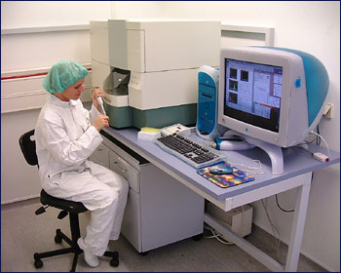

COMPANY PROFILE

MISSION STATEMENT

To ameliorate the “Education Sector”, “NGO’s”, “Health Care Industry", “Government & Private Departments” through enhanced technology and disciplined efforts. We utilize a scientific approach, determined spirit and expansive vision to pursue significant value that is unique to our firm.

INRODUCTION
BLAZON is a highly specialized firm in the field of BHU, RHCs, IT Equipments, Construction Materials, Hospital & School Furniture which is serving the community since 15 years, to support our customers BLAZON setup a "Technical Services Department ", at Rawalpindi/Islamabad employing a big team of highly qualified trained Technical persons for giving the services for the sold Equipment all over the PAKISTAN.

TECHNICAL SERVICE DEPARTMENT
This department serves the customers in.
- A technical application supports.
- Rapid delivery of products.
- Providing repair and calibration services for all brands of Equipment’s supplied by BLAZON.
- Troubleshooting of problems

BLAZON has a huge stock of more than 15,000 Medical, Scientific, Relief Material, Construction, Machinery Equipment from all over the world which is always ready to serve the customers according to their requirement.

BLAZON has a strong team of well qualified employees in different departments to serve the customers in all the relevant fields.
BLAZON have Overseas suppliers from top most countries like America, Japan, UK, Germany, France, India, China, Italy, Korea and many more. With this new technology in hands

BLAZON is always ready to fulfill any of your immediate requirements in this field. We attribute much of our success to the attention we pay to maintaining standards quality in service and fast delivery is a priority too. We maintain a large stockholding of Medical, Laboratory, Scientific, and Hospital Equipment & Lab. Chemicals ready to dispatch on requirement of our customers.
Your kind cooperation always helps us in bringing the “New Technology” from across the countries and is always solicited.

OUR COMMITMENTS
Every products undergoes inspection in order to satisfy the requirement of our customers and hence giving the class one services and maintaining the standard quality by providing the New Technology which helps in giving the result accurately.

For additional information about our products, application support or if you need products modified for your application, you can contact us at our designated e-mail address and our site offices.

In 1997, BLAZON steps first in the field of General Order Supplies, Medical and consumable business in order to serve Health, Science and Technology sector in the PAKISTAN. In this long run it had successfully served almost all the major departments of Ministries, Universities, Schools and many other sectors of government and also the ever blooming private sectors in the region. In fact it has become one of the top most and leading Medical companies.

We are pleased to introduce ourselves as a trading company very actively engaged in the sale of GENERAL ORDER SUPPLIES both on ex-stock and FOB/C&F basis through OVERSEAS PRINCIPALS”.

OUR VALUE ADDED CUSTOMERS

We are regular suppliers of:

- FAO Islamabad.
- UNICEF Islamabad.
- Community Uplift Program Islamabad.

Mountain Glacier Protection and Organization Islamabad.
- Helping Hand Relief and Development Islamabad.
- Islamic Relief Islamabad.
- Cordaid Islamabad.

Ministry of health

Women Health Project

Poultry Research Institute

National Institute of Health Islamabad

Pakistan Institute of Nuclear Science and Technology

Fauji Foundation Pakistan

Federal Government Services Hospital

Ayub Medical College

Central Drug Laboratory Karachi.

Oil & Gas Development Company Ltd.

NRSP

ARC, Islamabad.

Oxfam, Islamabad.

Islamic Relief, Islamabad.

& many more

BLAZON was awarded some major projects by the Government of Pakistan at Women Health Project funded by Asian Development Bank, National Tuberculosis Program funded by World Bank and World Health Organization. By the Grace of God the company successfully accomplished these tasks within stipulated time. Since then the Blazon became a name of trust and company is going upward.

OUR PRODUCT RANGE OF SERVICES

Medical

The Autoclaves, Automatic

Incubators,

Shaking Instruments

Deinizers

Blood Bank Refrigerators, Blood Roller Mixer, Blood Bank Shaker

Fume Hoods, Drying Cabinets

Water Distillation Plant, Water Baths.

Hapa Air Filtered Sterilizes, Oven.

Bio-Formenters, Laboratory and Industrial Scale

Growth Chambers, Seat Germinators, Green Houses

Humidity Chambers, Environmental Chambers

Luminar Air Flow Cabinets

Pharmaceutical Machinery

Complete Lab Furniture (Chemical, Glassware etc.)

Construction Materials

I.T. Equipments

General Order Supplies

OUR LOCATIONS

BLAZON has a head office in Rawalpindi/Islamabad with branch office in Peshawar to provide services in the Northern Region and a branch office in Lahore to serve the clients in Punjab and South Region in PAKISTAN. BLAZON also has a Service Centre for Machinery, Medical & Scientific Equipment in Rawalpindi, which is serving the community since from 1997 in the field of Engineering, I.T., Medical & Scientific equipments. This Department serves our customer in giving services against any manufacturing defects of its sold equipment and also maintains stocks of spare parts for the sold equipment. In this department the highly qualified Engineers and well trained Technical persons gives services to Our Customers.

BLAZON humbly request your valued organization to include us as your helping hand and look forward to serve you with our best and sincere efforts.

OUR TEAM

CHIEF EXECUTIVE OFFICER (CEO)

Ahmar Zaman Khan

Executive MBA (Marketing) MBA (M.I.S)

GENERAL MANAGER

Mohammad Shoaib Khan

SALES & MARKETING MANAGER

Atif Malik

MANAGER ADMIN

Munawar Khan

ASSISTANT MANAGER (Admin)

Nazarat Hussain

MANAGER

Tariq Mehmood

Engineer (Bio Medical & Machinery)

Muhammad Ibrar Bhatti

SALES OFFICER

Umair Ali Khan

SALES OFFICER

Ferhan Khan

ASST. MANAGER (Peshawar Office)

Javed Khan

ASST. MANAGER (Lahore Office)

Shahid Khan

LIST OF CLIENTS

- FAO Islamabad.
- UNICEF Islamabad.
- Community Uplift Program Islamabad.
- Helping Hand Relief and development Islamabad.
- Islamic Relief Islamabad.
- Cordaid Islamabad.
- NIH Islamabad.
- NARC Islamabad.
- PCRWR Islamabad.
- Zia Siddique Foundation Islamabad.
- Mtorway Police Islamabad.
- MGPO I-8/3 Islamabad
- IRC Islamabad.
- PAEC General Hospital Islamabad.
- Federal Government Services Hospital Islamabad.
- COMSATS Islamabad.
- Ministry of Food and Agriculture Islamabad.
- NVL Islamabad.
- PARC Islamabad.
- Atomic Energy Nilore Islamabad.
- Atomic Energy Nilore Islamabad.
- PIEAS Nilore Islamabad.
- ARC Islamabad.
- National Rural Supports Program.
- DGDP Ministry of Defence Rawalpindi.
- Fauji Foundation Rawalpindi.
- AFIC Rawalpindi.
- AFIT Rawalpindi.
- COD Rawalpindi.
- Fatima Jinnah Women University Rawalpindi.
- L&DD Lahore.
- Agriculture University Faisalabad.
- Live Stock Department Punjab.
- University of Peshawar.
- PPHI Peshawar.
- Provisional Aids Control Program Peshawar.
- Lady reading Hospital Peshawar.
- University of Faisalabad.
- Provisional Aids Control Program Muzaffarabad.
- Live Stock Department Muzaffarabad.
- Family Planning Department Muzaffarabad.
- DG Health Muzaffarabad.
- CMH Rawlakot.
- Agriculture University Rawlakot. And etc.
- Oil & Gas Development Company Ltd.
- Institute Of Space Technology, Islamabad.

